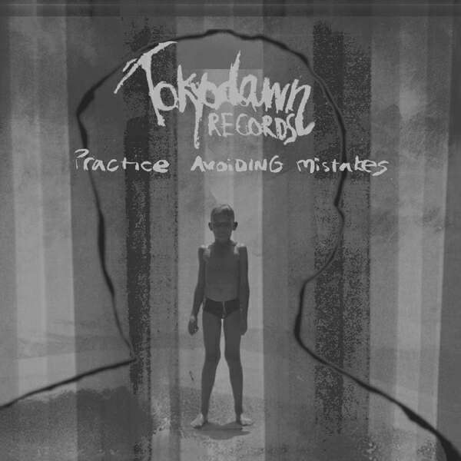 | tokyo dawn records.  http://www.tokyodawn.net  established 1997.  tdrlp01. practice avoiding mistakes lp.  intuitions:initiatives:introductions.  our hardware debut. finally unfinished.  distribution requests: info@grooveattack.com  release date: europe dec’03, usa feb’04.  further promo requests: info@tokyodawn.net  
1 causes & forces – there’ll be a new purpose 1:06
krii & prymer (producers). recorded on the street and at the tokyodawn studios virrat & weimar.
2 comfort fit – walls and shells and flexibility 3:18
boris mezga (producer). recorded at the cotton fields, south germany. full length version released as ‘mauern und schalen
und beweglichkeit’ via megahertz.org.
3 anthony baggette – summer in the hood 3:51
anthony baggette (spoken word). causes & forces aka krii & prymer (producers). andrea schätzle (flute). selim sonos (bass,
keys). originally produced by robert koch and walera goodman for hamton recordings. recorded at the hamton & ragson
studios berlin and at the tokyodawn studio weimar, germany.
4 twice & fedeb – yellowstar (burger mix) 2:00
lorenzo mangani (producer). frederico debenedictis (bass). recorded at the tokyodawn studio bologna, italy.
5 the groove guerrilla – that day 4:21
nicole hadfield (vocals). jan himmelsbach (keys). dj slick (scratchs). armin dörfert (bass). milian vogel (sax). michael
koschorreck (guitar). recorded at studio b5 mannheim, germany.
6 opossum feat. bazooka joe gotti and leeroy brown - mamaronie 3:39
mike dietrich (producer). josé simon (rap). christopher smith (chorus). markus nachtigal (mixing).
dj opossum appears with friendly permission of arabella musikverlag/topp entertainment.
leeroy brown appears with friendly permission of bmg ufa mv/edition tamsongs.
bazooka joe gotti appears with friendly permission of ill aztec publishing los angeles.
7 krii feat. charlie one – too good to waste 3:59
krii (producer). charlotte fairman (vocals). selim sonos (guitar, bass). thanks to juanita juarez. recorded at the sKlenik F X
studio (prague), at the ragson studio (berlin) and at the tokyodawn studio virrat, finland.
8 comfort fit – kurz vor danach ganz 4:03
boris mezga (producer). recorded at the cotton fields, south germany.
9 sherlock – good morning city 0:43
sherlock (producer). krii (mixing). recorded in sopot, poland.
10 blue eyes – phenomenal man 2:58
farley randall (producer). alicia rene aka blue eyes (vocals). recorded at bangtown recordings flint, michigan usa.
11 opossum feat. missamadina – too late 2:06
mike dietrich (producer), missamadina (vocals). recorded by opossum@home in leipzig, germany.
12 comfort fit – go on, take it further 1:08
boris mezga (producer). recorded at the cotton fields, south germany.
13 saine – equanimity 3:57
lauri saine (producer). krii (mixing). recorded in finland.
14 prymer & blaktroniks – pimp knowledgy (krii remix) 3:54
blaktroniks (spoken word). krii (remixer). originally produced by prymer. recorded at the underground music seminary 2001,
silicon valley, usa.
15 looza – known 2:25
looza (producer). dj opossum (scratches). recorded at the tokyodawn studio leipzig, germany.
16 mentz – (a)part from footsteps 1:21
stephan raab (producer). recorded at the smak studios, the hague, the netherlands.

17 LaShawn – of the essence 5:23
daniel anttila (producer). recorded at the nothern polar movement studio malmoe, sweden.
18 anthony baggette – brown said 3:09
anthony baggette (spoken word). krii (producer). originally produced by robert koch and walera goodman for hamton
recordings. recorded at the hamton studios (berlin) and at the tokyodawn studios virrat, finland.
19 prymer feat. claudia nehls – daydreamer 3:32
prymer (producer). claudia nehls (vocals). selim sonos (bass). krii (mixing). recorded at the tokyodawn studio weimar and at
the ragson studio berlin, germany.
20 dharma one vs. jukka eskola – the waves 4:19
jouni helminen (producer, fender rhodes). jukka eskola (fluegelhorn, fender rhodes). emma salokoski (vocals). written by
jouni helminen & jukka eskola. recorded at the arabia studio helsinki, finland.

the tokyodawnsoullabs
tokyo dawn records is the name of our tough little unit of producers, vocalists, jazz-instrumentalists, djs, designers and video-artists.. we’ve been releasing music on the internet for free since 1997 – improving skills, networking, studying underground strategies, gaining attention, avoiding musical scenes and sometimes even receiving an award or two inbetween.. we stepped onto the scene as one of the very first ‘opensource music‘ communities around and worked hard on improving our output ever since, even leading to special releases by domu, blaktroniks, seiji, alistair colling, sweet abraham, sad rockets, lackluster and many others.. tokyo dawn became a fix part of nearly all articles concerning the free music movement and the netlabel scene !
but unlike the press, we definitely don’t see tokyodawn as an internet project- it’s music first, and our collaborative struggle is second, trying to be able to live by and for our idealism and taking our art to higher levels.. we’re now doing our very first offline moves as record company since we feel obligated to build up better perspectives for our artists and to make their struggle easier- realizing that they just can‘t get the attention and possibilities they need to continue making music this way if only releasing online.. seems like we’re just in time before the cd market completely breaks down! but don’t worry, we’re not going to stop releasing free music- we’d just like to use this cd as an opportunity for you to focus on our soul&skills and not on our net projects this time.. thanks for your attention!

tokyo dawn artists featured on this record.

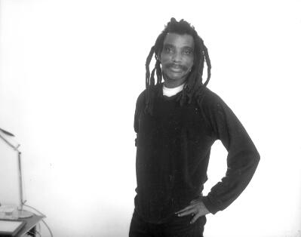 | anthony e. baggette  the poet und ex-mtv-moderator ('talking jazz', early 90s) knows how to focus serious topics in his own and very charming way, spiced with ironics and pop-metaphors.. anthony baggette (51) moved from ohia/usa to berlin in the early 80ies and was very active in berlin's jazz- and funkscene till the late 90ies. he's responsible for one of the biggest acidjazz hits from 1994, even reaching top10 in the uk! he's the winner of the first poetry slam in berlin and has played with his band 'jazzoetry' in about every live club in town already, leaving impression with his special remake of john coltrane's 'love surpreme' amongst other songs.. anthony also worked together with the jazzanova crew for several years, doing radioshows and clubnights at the 'delicious donuts‘ in
berlin.. he just recorded and played with theriak on the business class explosion tour in berlin and the tokyodawn producer team is currently working on his first solo album to drop on our label this year! the first fruits of our cooperations can be heared on tdrlp01.. his other current project keeping him busy is to establish a new club location for theatre, poetry and music together with the owners of the sage club in berlin..

blaktroniks
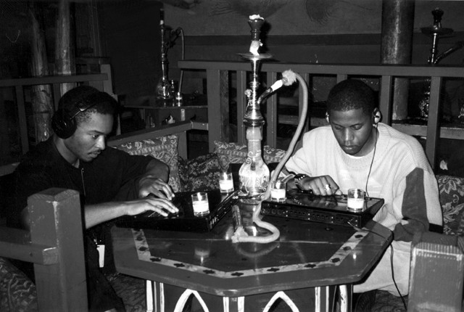 | the branch of physics that deals with the behavior of free blaktrons, blaktrons being the darkest known huemans, constituents of all huemans..  “we bring you glad tidings from the noble planes of human suffering. grace, mercy, and sacrifice are the ingredients which constitute 'return of the afronaut'. like the title suggests, we have returned, but not without mission. we are in search of god and the god-like. SALAAM.“  the name, blaktroniks, is a metaphor to connote the ability to manipulate a waveform to simulate a variety of naturally occurring phenomena, and transmit it, thus creating a transformation matrix that allows the receiver to move freely from one thought to another.
blaktroniks, whose formers are the songwriters edd dee pee and x-ray, started in 1996 in the bay area, when x-ray moved in from minneapolis and edd from detroit. the two met at the insistance of a mutual friend after she heard x-ray was forming a company specializing in digital media. the two quickly realized each other's potential to produce compelling digital media, and set out to record their first full-length cd titled "return of the afronaut". the two then ventured across america, and europe to promote it. upon returning, they completed three more full-length cds, 1997's "process of illumination", 1998's "national tantrum", and 1999's "blaktroniks", before releasing two critically acclaimed EPs, "movement : moment" and "truth and desire" (including remixes by domu and mike grant) on the indie label moving records. coops with jonah sharp, larry heard, prymer and others followed, as well as releases on tokyo dawn (2001-2003), electuz (2001), sofa (2001), die lounge (2001), the soul magazine (2002) and reflective (2003). and not to forget the two tours "moving reflection tour" in 2001 with prymer and selim sonos and the seduction at 33 1/3rd moving records tour together with mike grant (moods'n'grooves) and move-d (source). the blaktroniks-"family" includes various artists and there are more projects which will see the daylight in the close future on moving and tokyodawn - so better be prepared for the next level shit - cali-tek 2003 !

blue eyes
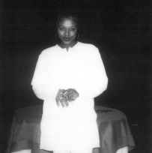 | the deep soul music of blue eyes is flavored with influences of such musical greats as aretha franklin, nina simone and leontyne price..  alicia rene aka blue eyes, nicknamed for her natural eye color, left flint to attend college in chicago, but soon landed in NYC, where she worked with respectable artists in the r&b, hip-hop, and jazz-world: mos def, the last poets, d'angelo, a tribe called quest, saul williams, jamiroquai, common, wu tang etc etc - most recently even dwele and slum village, with who she toured through europe this summer, including stop bys at the gilles peterson show, at the montreaux and north sea jazz festival etc.. after crossfeatures on moving records, infracom and sony japan, alicia rene is now kicking it on tdrlp01 with her rnb-jewel 'phenomenal man'. this april was a special highlight: blue eyes and defcon5 came all the way from detroit to europe to headline the tokyodawn/moving ‘business class explosion tour‘! but we also spent some time in the studio together, not just in the clubs- so watch our for some further treats from alicia coming your way on the next tdr 12"s soon!
bram nelson
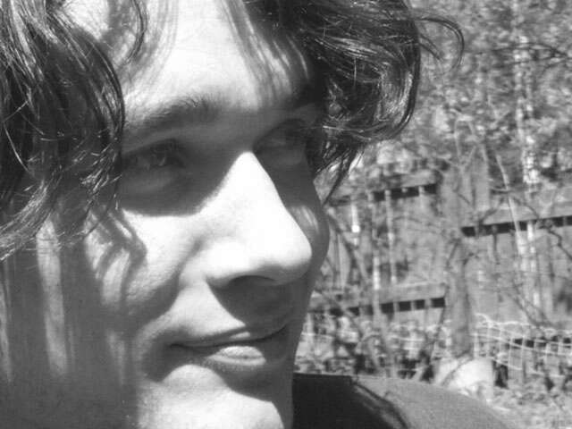 | himalaya-explorer and globetrotter, who has spent many years living abroad in africa, france, middle finland and even in kashmir.. his love for breakbeats and electronic music already started burning with 14, making jungle music with fasttracker just like several other producers at tokyodawn back in the days.. later he discovered gilles peterson's 'worldwide' radioshow, which had heavy influence on his music, so bram and four friends built up a studio in finland and bought hardware tools to advance from the tracker sound.. their studio split up three years ago and that was the time when tokyodawn's path crossed with bram's.. meanwhile he's not just pushing his dopebeats forwards as always, but also making videos, designing, learning instruments,
writing poems and also performing his art.. bram persuades the essence of different nations and cultures. he loves italian espresso, romanian monkey brains and sheep liver in kashmir, even tho he's a vegetarian.. and he's also the graphician, who made the artwork for tdrlp01 - there you can see a tiny and happy bram smiling under the sun of senegal.. rumours are he has been recently seen doing theatrical adaptions of 'the little prince' on the marketplace of helsinki, using a discoball to represent the planet the little prince lives on.. look out for the seven headed bram nelson band touring through europe late 2003, starting off in ylivieska/finland (where they expect to get hit by flying bottles) and also finding its end in finland- at the finnish avantgarde art festival 'avanhtarde'..

charlie one
 | originating from essex, england, vocalist charlie one (charlotte fairman) has wound up living for the past five years in the beautiful city of prague. it is here that she has built up quite a reputation in the dance music scene with her band ohm square & by cooperating with many other music projects and ventures. ohm square have won two czech grammy awards for project of the year in 1999 & album of the year in 2001, both in the dance music category. charlie has written & performed on the soundtracks of four successful czech films: samotari (‘loners’), andel exit (‘angel exit’), eliska ma rada divocinu (‘eliska likes it wild’) & most recently devcatko (‘girly’). but her varied lifestyle doesn't just stop at singing: charlie landed the part of a british WAAF in the film 'dark blue world' which is the biggest czech production made so far. you can also see her on the silver screen in the short film fricasse, due for release any day now.. being involved with a large part of the tech-house scene in south london, having lived
there for five years before moving to prague, charlie also decided to set up a dk booking agency for UK artists in prague. other UK projects which featured the sweet vocals of charlie one include 'wubble u ' (remixed by freestylers, spooky, richard h.kirk etc) & 'gadzouk'. she has just set up a home studio and is about to embark on writing her solo album, something she has thought about for a long time..

claudia nehls
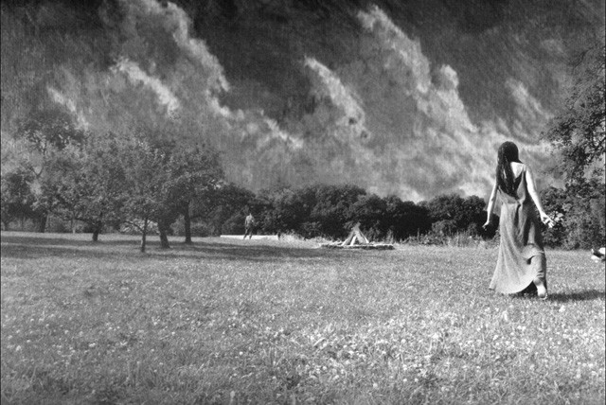 | the jazz vocalist claudia nehls doesn't just record with us, she also accompanies us as singer on some of the tdr road and radio shows, even though she's is still trying to hear as little music as possible – aiming to gain more inspiration from the real world surrounding us instead. no tv or radio- just her farm in the woods, where she grows her own fruits and vegies.. she's playing the piano since 14 years meanwhile and is intensifying her studies in jazz vocals, when not acting and composing for theater or playing in bands- funk, soul, house, hippy songs, reggae, experimental jazz, all kinds of music.. but besides all that vibing, claudia sells dream catchers for a living..

comfort fit
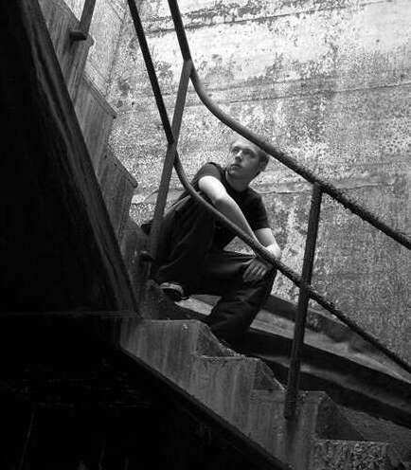 | boris mezga aka comfort fit started making music with 4 years using a yamaha-vss 200 minikeyboard including a minisampler. he bought his first two decks with 12 so that he didn't have to cut his mixes using tapedecks anymore, and quickly became one of germany's promising newcomer-djs. he was already spinning at clubs, cafes and on radio and also getting props from the regional press for his techno mixing skills with merely 13 years. 1997 he discovered ninja tune and fell in love with their retro-organic sounds, which helped him discover hiphop in young years. 2001 he fucked up his final school exam due to the work on his first album titled 'museum', released on megahertz.de. the three comfort fit tracks on tdrlp01 will give you reason enough to eagerly await his second album to drop on tokyo dawn later on this year. he is currently working together with talented mcs on some bouncers and we surely believe to have found one of the hottest newcomer hiphop producers around! it even seems like some people agree, regarding his tokyodawn-remix for a major-top10-act on universal jazz which just got released this june!

dharma one
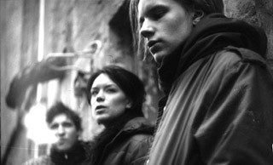 | vocalist emma salokoski, trumpeter jukka eskola and beatjuggler jouni helminen provide us with a flavasome slab of jazz-tingled soul, 'the waves'. jukka eskola is part of the famous nujazz-combo 'nu spirit helsinki', who have previously recorded for compost and guidance records.. emma salokoski is the vocalist of the successful rnb-formation 'quintessence', who have recently released some great rnbsoul-12"s on dorado uk, alongside dharma one on the beats.. his latest soloprojects on nine2five records have recently received tons and tons of airplay and djchart-entries around the world, from jazzanova to

patrick forge and his latest hit 'belong' even got featured on gilles peterson's latest trustthedj compilation. we got to know dharma during his days in the netlabel scene alongside mono211, a very respectable netlabel who have been doing their thing even longer than tokyo dawn. he has currently got some releases in the pipeline for moving shadow, mangofunk, compost and hospital, plus another one or two for in store for us for tdrlp02.. we think that 'the waves' is the perfect tune to finish tdrlp01 - "goodbye my beautiful friend, until i see the light again" !

dj opossum
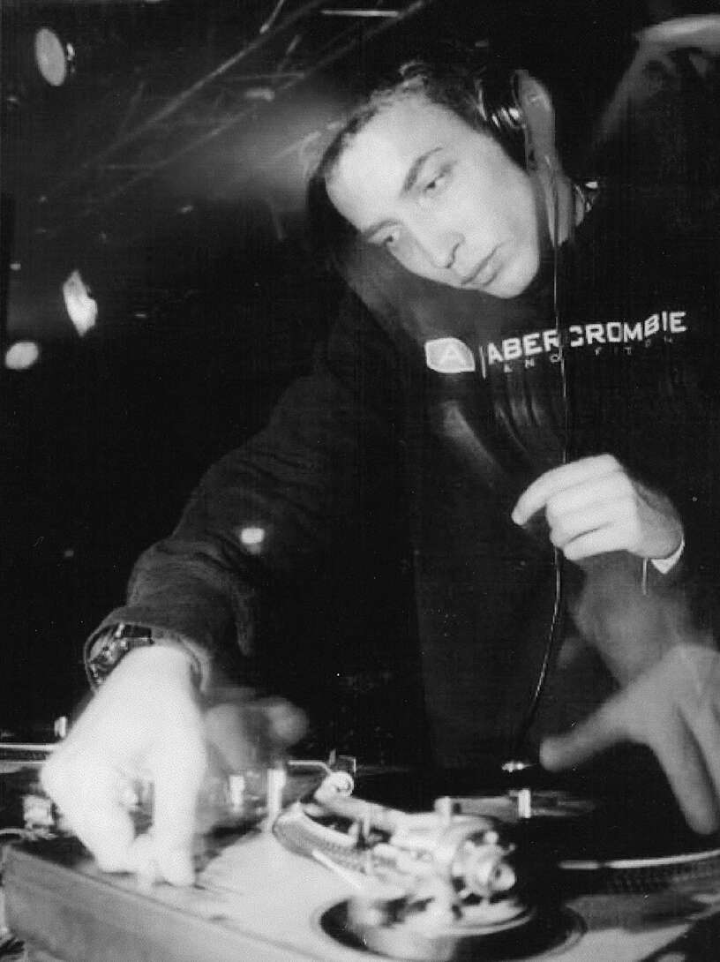 | dj opossum is one of those few oldschool hiphop cats in germany, who have been in this game since the start.. he has produced some of the better german hiphop albums around (most recently the chima album for emi records), and has also produced beats for international hiphop artists such as guru or bazooka joe gotti, who is also featured on tdrlp01 with a lovesong for all mothers across the globe. opossum has been the german support-dj for jazz-superstar herbie hancock and for the chartbreaking soulsinger xavier naidoo recently. his second song on tdrlp01 is a rnb number introducing the vocalist miss amadina to the scene and to tokyo dawn records.. they'll both also be featured on the next tdr 12" and there are some nice remixes to follow too ..

krii
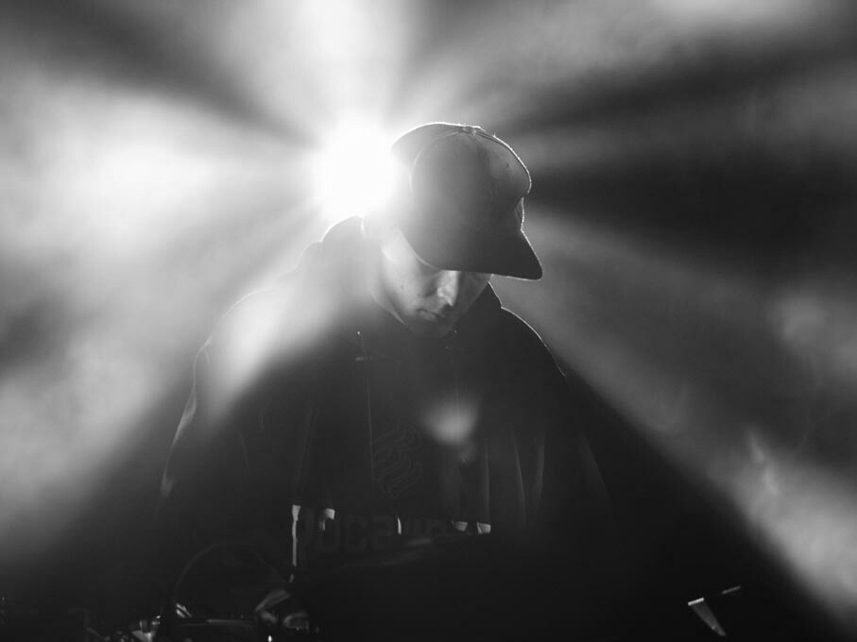 | tokyodawn's finest! known as krii, resound as well as forming the 'causes & forces' team together with prymer - krii is an important backbone of the tokyo dawn sound. he's also the most productive musician from the tdr hoods – livitingeatingbreathing music with an incredible amount and quality of output! his musical ambition has led him from demolishing his mother's kettles with kitchen hardware in the early 80's into establishing his sound in the forefront of electronic music today. there have been many musical perioids in between – from playing several traditional finnish instruments to playing guitar and bass in
a hardcore punk band. ever since he first started creating electronic music back in 1995, krii has been living it. deep grooves, moody soundscapes and advanced beats are characteristic to the profound style. what ever the kind of music he happens to be working on - it's music that is not made to be defined. specializing in music and sound, he began studying media communication and economy at pirkanmaa polytechnic in the year 2000 and is set to graduate soon. besides his official studies he spends lots of time on reading and absorbing information on his free time. with his professional production and mixing skills he has helped many bands and artists achieve their vision in a fresh and innovative way. with successful remixes under his belt for several artists and bands such as asc, dephazz, blaktroniks and bergheim 34, he is a sure choice for solid and fresh sounding remixes. with music released in the past on labels like source records and moving records and many essential releases in the pipeline for labels such as warm communications, covert operations, klang elektroniks and of course tokyo dawn records, krii is set for the future.

LaShawn
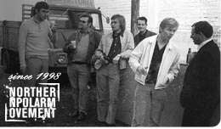 | LaShawn and his magical turntablism project present a program of tasty standards- some tried and and true evergreens and others of more recent vintage.. supported by what could be a lush, full orchestra, LaShawn’s instrumental genius is indeed a joy to the ears.. whether you are in the grand canyon or in the streets of paris or just with grandma frolicking on the front lawn, you‘ll find that LaShawn’s music is endlessly useful.. it adds a distinctive and professional flourish to both the art and the enjoyment of everyday life.. note how
the music, played loud or soft, according to your taste, accents the humor or the drama of any situation by adding an audio impression to what was previously only visual. these soul arrangements are the result of a joint program to research all kinds of motion-picture musical soundtracks, giving praise to its architects since the 50ies such as elmer bernstein, quincy jones, john barry, ennio morricone and many many more.. please also note that LaShawn is not a person, its merely a name that represents this sweet music..

mentz
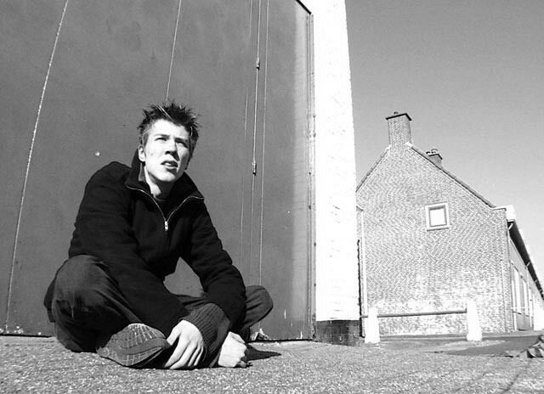 | stephan raab aka mentz (aka meightk) is a musician from the lowlands, living in a city where an international court, a national government and a tolerant drug policy go hand in hand. He has been down with the tokyodawn movement since many years already, representing us in the netherlands.. as if that weren't enough, he's also been teaching children, working in a museum and in the tele-communication industry as well as studying interactive design part time.. he mostly finds his inspiration in the cinematic jazz and funk from the years of his conception, the 70ies.. slowly getting where he wants to go, he's featured on tdrlp01 with a short but gorgeous interlude, underlining his musical statement for
those who haven’t catched his vibes online so far.. since two years he is musically also involved with our friends at the uprising jungle-crew ‘scientific‘, where he releases under the name ‘meightk‘..

prymer
 | director of the tokyodawn soulcircus- a jazzfunksouldubhiphoplover who has his musical roots in classical music.. the two main projects he is currently producing for tokyo dawn are  causes&forces – moody and farout posthiphop-electronica in cooperation with tokyodawn's finest krii &  theriak music for soulful lovers and sentimental cats- warm soulfunkjazzpop with selim sonos (guitar+bass) and milian vogel from the groove guerrilla (sax+flute)..

selim sonos
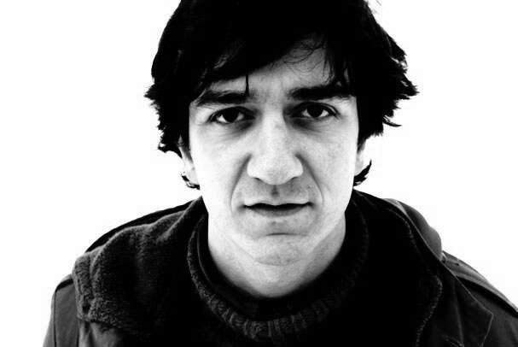 | multi-millionaire and multi-instrumentalist, who has already gained lots of live jazz experience in the many good bands he has played with: claz (1995/98), afoodmport (1998), twiceland (1999), özkan & vougiatzis (2002/03). and he's even the star of a short movie for berlin tv showing what we musicians take upon us to live the life we chose to live. selim has been prymer's musical partner in crime since many years already, even tho they meanwhile live in different cities and prymer still isn't a millionaire. selim is the secondly most often featured artist on the 'practice avoiding mistakes' lp, playing bass, guitar and/or keys on nearly every second song- his jazz and funk surely is a strong
backbone for the tokyodawn-sound currently evolving. selim also just jammed with his band 'theriak' together with prymer and milian vogel (/groove guerrilla) during the tokyodawn/moving 'business class explosion' tour this april.. theriak is a medieval panacea, consisting of nearly a hundred different organic and animal substances, boiled together for an antidote against nearly all kind of disease, may it be affecting either mind, body or soul. the main ingredients of theriak are boiled snake-meat and opium, a remedy gold prescribed by dr. feelgood. just that the ingredients of our 21st century theriak are funk, hiphop, popjazz and soul- combining moody jazziness with modern dance grooves for an enjoyable midnight shuffle. no placebo funk tho..

the groove guerrilla
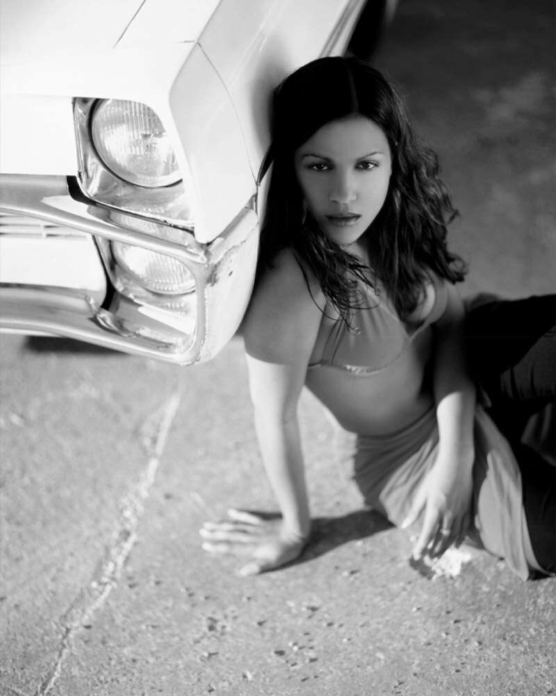 | a new soul/r'n'b formation consisting of five musicians from the new german soulcity mannheim. the band line up: nicole hadfield (vocals), jan himmelsbach (keys), armin dörfert (bass), milian vogel (drums, sax), dj slick (turntables). The producer of the band is gagey mrozeck, who is also responsible for the sound of german no1 artists such as the flames ('angel') or xavier naidoo. founded in 2001, they have already won two bandcontests, have played together with german hiphop-star curse, and performed at the mtv-campus-invasion 2003 (together with fettes brot, skin, HIM, and others). while rocking their audiences all over germany, the groove guerrilla are in the final stages of producing for their first full-length album. milian vogel and tokyodawn-artist selim sonos first jammed together as members of the jazzband 'afoodmport' 1998. today milian studies jazz at the HdK berlin and has already got used to his a-grades while continuing his work in different styles; i.e. performing with ghanaian hi-life superstar kojo antwi (together with former jamiroquai guitarist simon cats, and kwame yeboah, keyboarder for craig david & ms dynamite). milian is also an essential backbone of 'theriak', a jazzpop-band with selim sonos and prymer..
theriak had their first dozen of gigs during the tokyodawn/moving ‘business class explosion tour‘ april'03 and are currently working on their first album for tdr. and there's more from the groove guerrilla than just their tdrlp01 treat! catch them on their ‘ghost tour‘ in south germany this summer so long! the tour dates can be found online at http://www.tokyodawnrecords.com.

twice
 | aka 'ethehot' aka lorenzo mangani was born in perugia/italy at 5 o'clock in the morning on some lazy april fool's day, and that was about the only time he woke up early in his whole life.. he's often lost in time and disappearing with no prior notification, but when it comes to good music you bet he'll be showing up.. twice first experienced sampling at early age, which meant the kid wasn't good for park games and sports any longer – and that was just the beginning of a lifetime loop (fw+bw).. he then dedicated several years into playing and studying music, modding and building guitars and playing piano, just to find out that music owned him before he completely switched to the woodless instrumentations.. currently
residing in bologna, twice' is currently working in the IT branch yet hoping to get out of the office life subroutines soon.. he entered the tdr family in 2001 and elsewhise he'll be getting his musical inspirations from those wild buds burning, sticking to sweet hiphop-touched grooves, emotional chords and 80'ish basslines.. twice is currently working on his debut fullength-album for tokyo dawn records - and let us tell you that it's more than just promising in it's current stage! for this album, twice is working and producing "four handed" with the talented bassplayer, producer and dear friend fedeb, aka federico de benedictis. their latest coup was to hit chart position #4 of the italian alternative dance charts with a cover version of bob dylan’s “visions of johanna“..

